4th database

During the undo phase, the recovery system reads the log in reverse and stops at:

The start record for the last transaction in the active transaction list

T1 reads salaries of some Accounting department employees

T2 transfers Maria Rodriguez from Accounting to Development

Tz commits

T1 reads salaries of remaining Accounting employees

T1 computes and writes total salary of Accounting employees

T1 commits

Phantom read

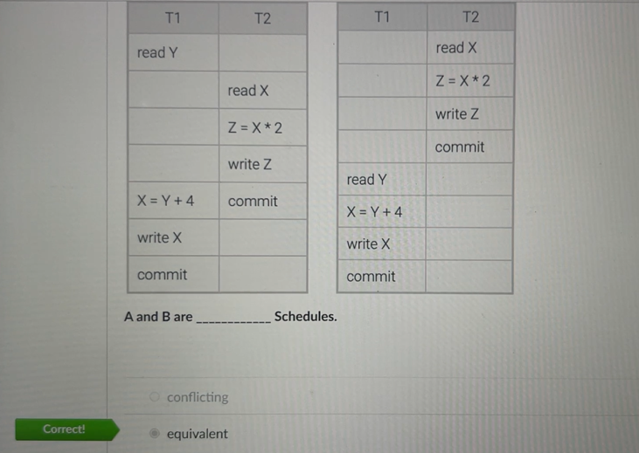

Verifying the identity of a user is called

Authentication

_Assume existence of user Assistant Manager assistant.

What privilege should you grant to assistant who needs to know only average department salaries? Express it in proper SQL.

GRANT _ON Deptinfo TO assistant

SELECT

ROLLBACK TO statement erases saved data for zero, one, or many savepoints.

How many SQL statements must be in one transaction?

At least one

A database uses basic two-phase locking. Transaction A takes an exclusive lock on X.

Transaction B requests a shared lock on X. When is the shared lock granted?

During the contract phase of A

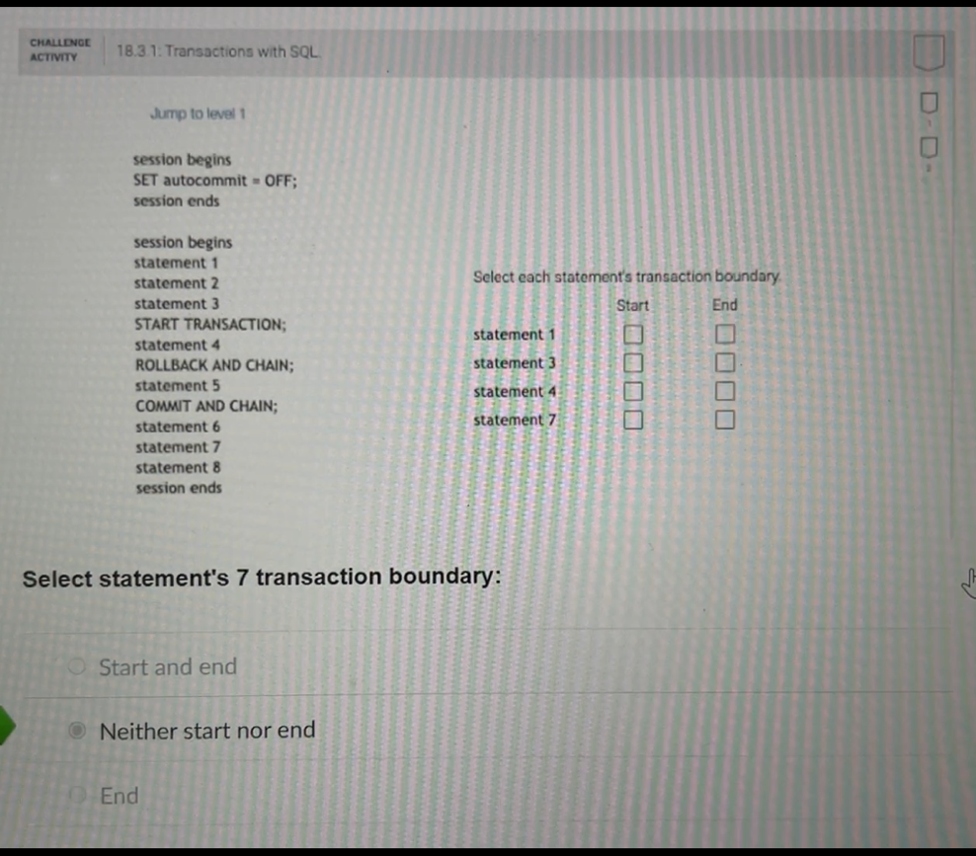

A database uses strict two-phase locking. Transaction A takes an exclusive lock on X.

Transaction B requests a shared lock on X. When is the shared lock granted?

After A commits or rollsback

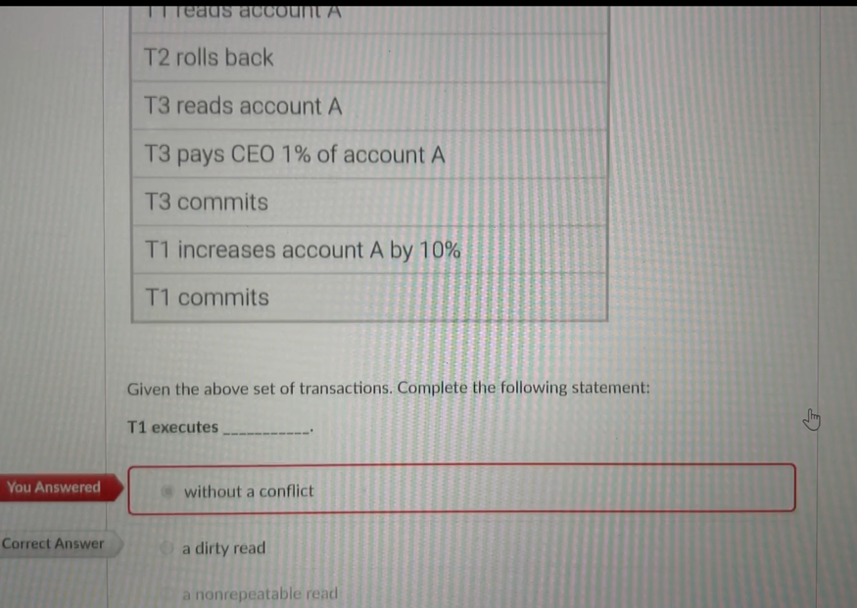

Select the ACID property violated in the following example:

Two transactions run in parallel to set an account's balance to different values.

Isolated

_durability_requires that the effects of a committed transaction be

permanent, so they must survive the loss of main memory, loss of disk storage, and failures during data transfers to disk.

Procedures that monitor actions such as changes to the database and cause an action to be taken when certain conditions arise are called

Triggers

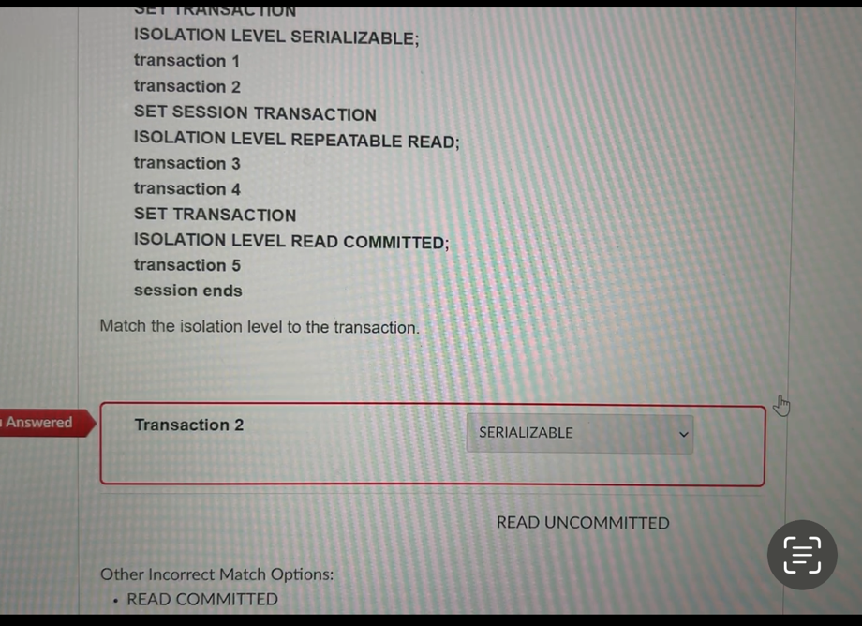

Log record 1: start T1

Log record 2: start T2

Log record 3: update T2, Z

Log record 4: undo T2, Z

Log record 5: rollback T2

Log record 6: update T1, y

Log record 7: commit T1

For unknown reasons, an application program freezes. The data administrator forces termination and restarts the application.

System failure

ROLLBACK statement reverses all changes made by a transaction.

The transaction is always durable.

False

All of the following are security tools EXCEPT

Constraints

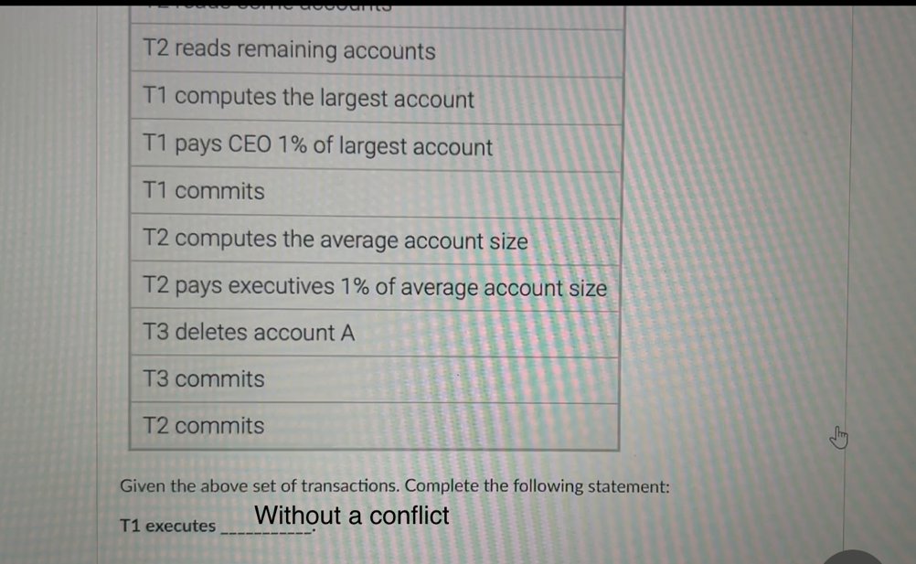

Which two-phase locking technique has, in effect, just one phase?

Rigorous

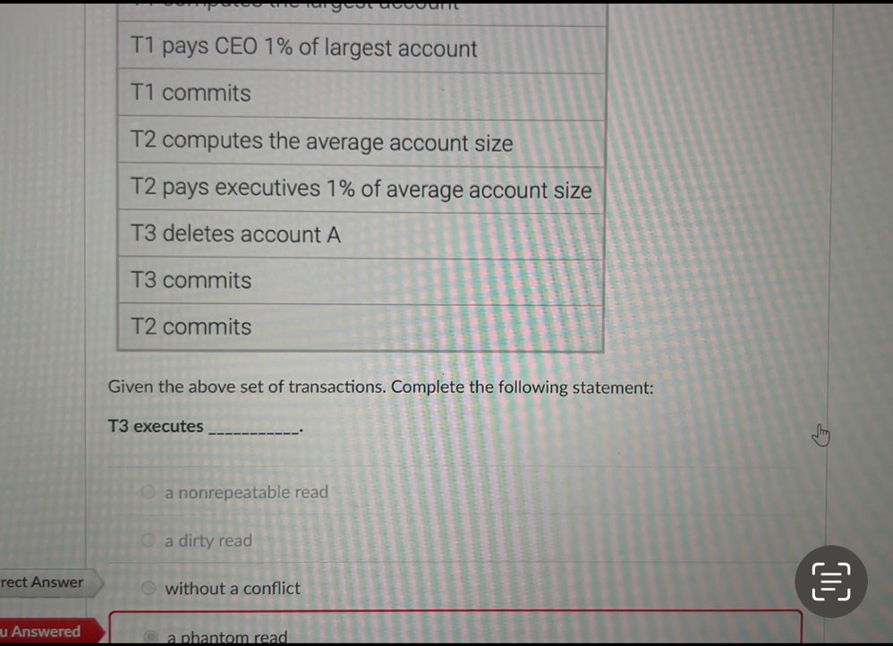

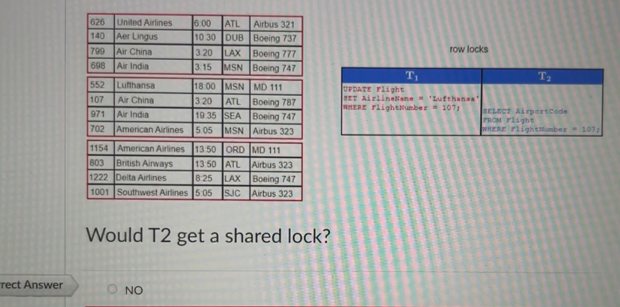

A transaction increases all employee salaries by 10%.

Due to a system failure, increases for only half of the employees are written to the database.

Atomic

|  |  |
| --- | --- |
|  | A transaction saves a row with a foreign key.  The foreign key is not NULL and does not match any values of the corresponding primary key. |

Consistent

|  |  |
| --- | --- |
|  | Two transactions running in parallel reserve the same seat for different passengers. |

Isolated

|  |  |
| --- | --- |
|  | A transaction withdraws $500 from account A and deposits $500 in account B. |

|  |  |
| --- | --- |
|  | The withdrawal and deposit are written in the database, but due to a disk drive failure, the information is permanently lost. |

Durable

SET TRANSACTION

ISOLATION LEVEL READ COMMITTED;

transaction 5(READ COMMITTED)

session ends

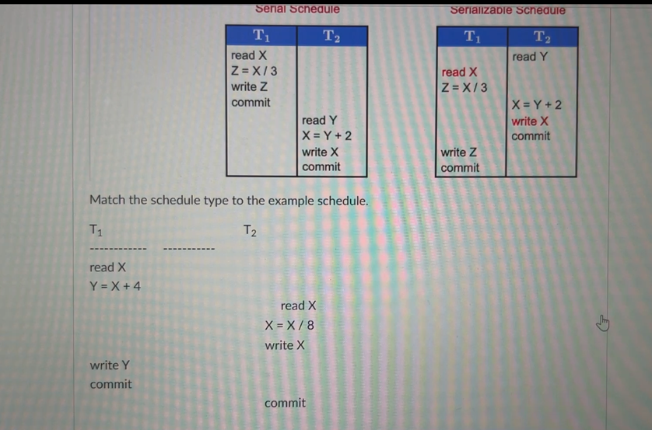Serializable schedule

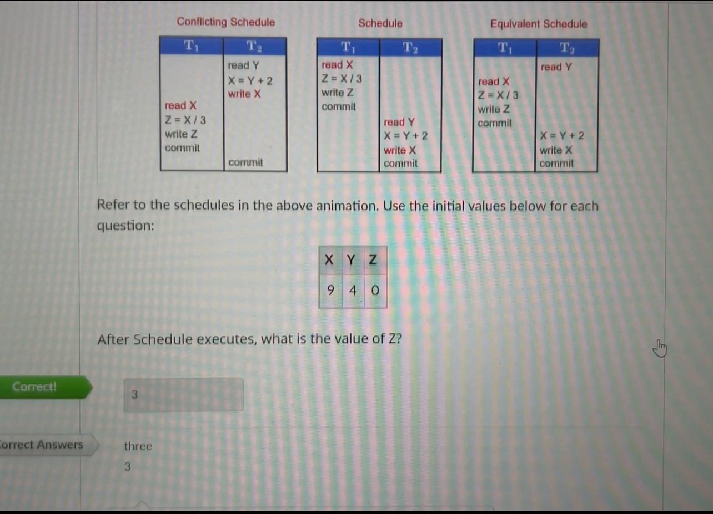

Transaction A writes data. Transaction B reads the data. Transaction A rolls back before B commits.

Cascading

With a cold backup, recovery from storage media failure reads the log:

From the latest checkpoint

During the undo phase, the recovery system writes compensation records for:

Transactions that do not commit or roll back following the most recent checkpoint

One transaction can hold an exclusive lock while other transactions hold

Shared locks on the same row.

False

With a hot backup, as a transaction executes against the primary database:

Log records are sent to the secondary database.

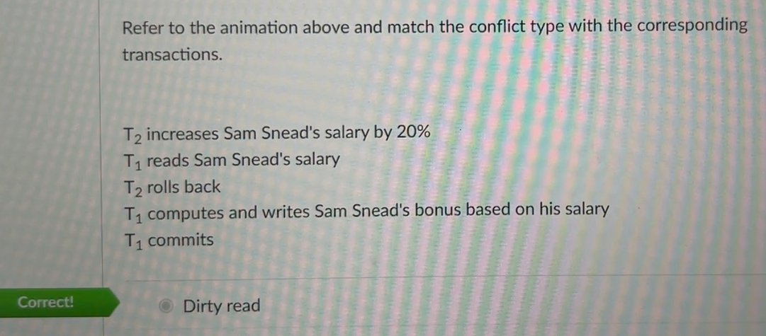

For a schedule to be serializable it must

produce the same result as an actual serial execution

After a transaction commits, the transaction can be rolled back:

Never

Deadlock can be spotted by looking for which of the following in the wait-for graph?

A cycle

A buffer manager retains ____

from the ____ to reduce data access time.

Data blocks, file systems

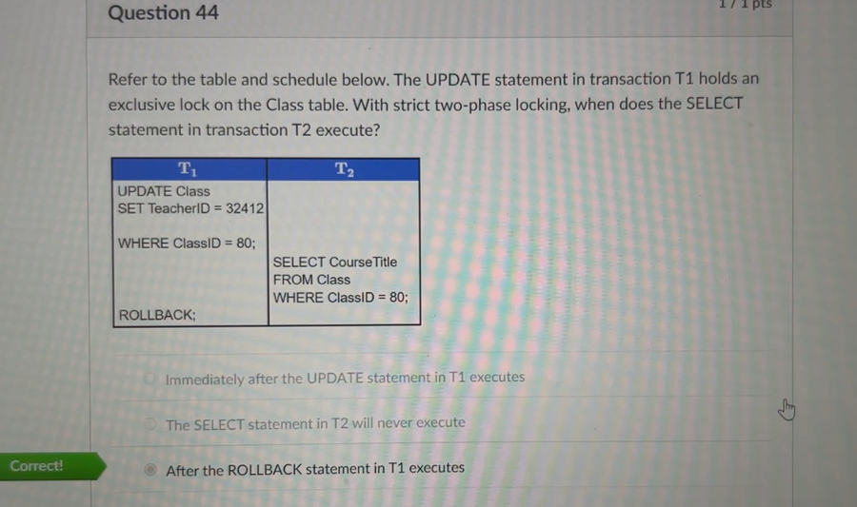

Hot backup a recovery technique that creates a nearly synchronized backup of the primary database on another database server.

In a deadlock all transactions come to a halt and remain at a standstill until one of the transactions is aborted.

In an online bank application that transfers funds from a checking account to a savings account, if a debit is made successfully from the checking account, the __ property ensures that the corresponding credit is made to the savings account.

Atomicity

Which deadlock management technique automatically rolls back a transaction when a lock is not released in a fixed period of time?

Timeout

A database administrator creates a MySQL statement with incorrect syntax. What does MySQL Workbench display when the statement is executed?

Error code

Schedule is a sequential order of database instructions for multiple transactions.

A database administrator is updating one of the tables in the database. Which of the following techniques can prevent other database administrators from doing concurrent transactions to the same table?

Locking

Which MySQL layer interacts directly with database users and administrators?

Tools

A developer wishes to link to a database with a utility created in C. Which MySQL component does the developer use for the link?

API

In which isolation level can dirty reads occur?

Read uncommitted

Which isolation level prevents dirty, non-repeatable, and phantom reads?

Serializable

When using the MySQL Command-Line Client, which character ends a command?

;

In MySQL, which of the following SQL operations always commits immediately?

CREATE

When using the MySQL Workbench GUl, which icon will execute an SQL statement?

Lightning bolt

In the query processor layer, the query optimizer generates

Execution plan

Video2

After a rollback, the database restarts a transaction:

Sometimes

statement erases saved data for exactly one savepoint.

RELEASE SAVEPOINT

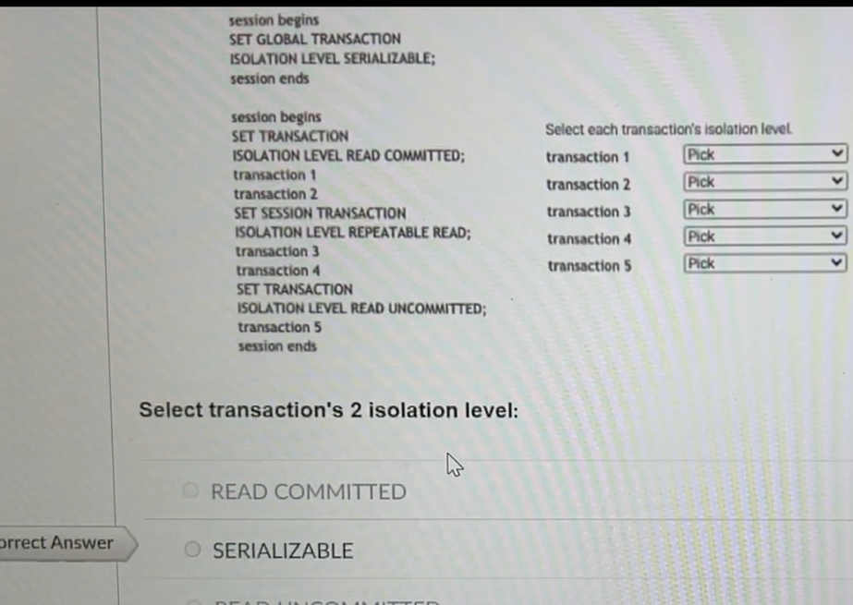

A graphical depiction of the execution sequence of transactions is called a

Schedule

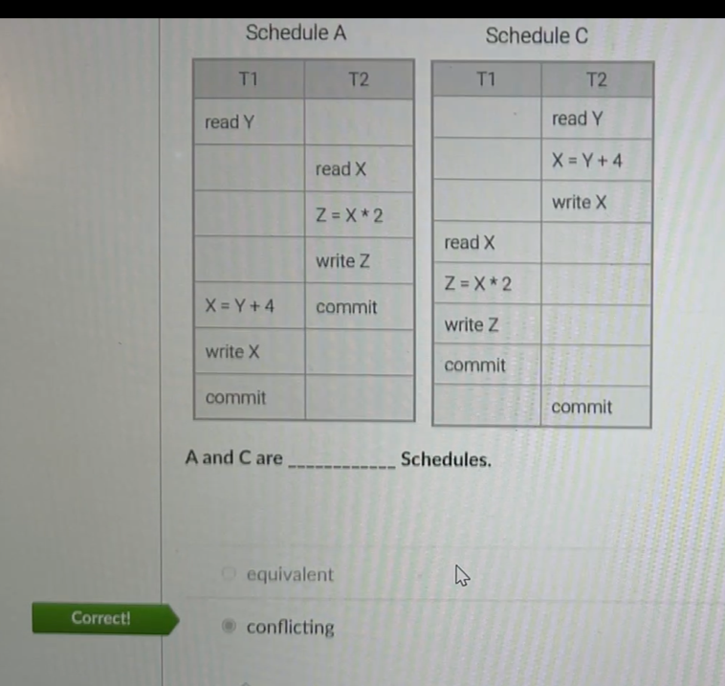

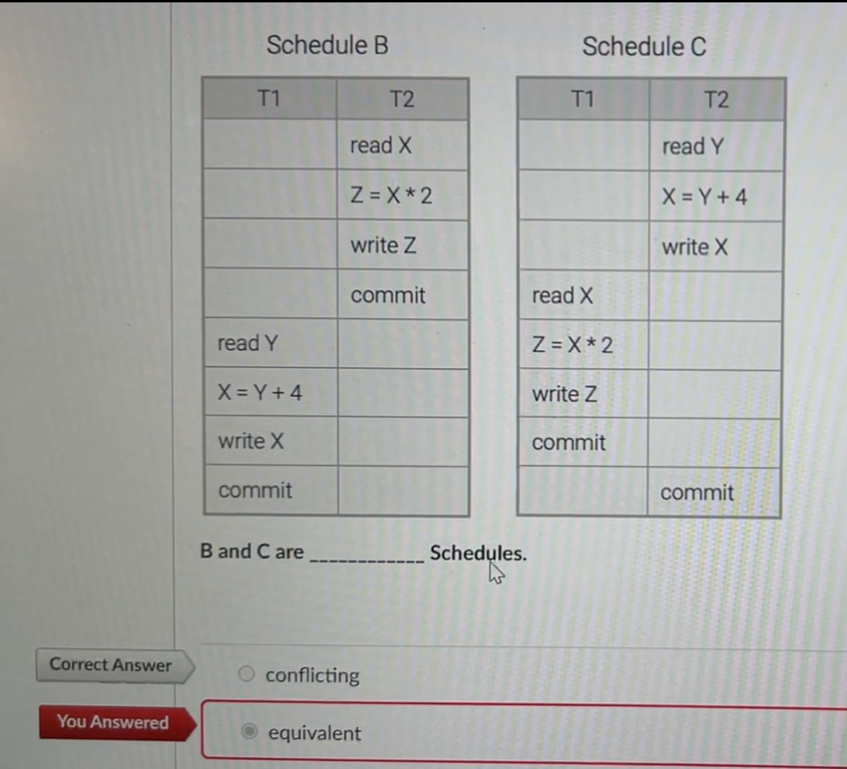

T2 increases Sam Snead's salary by 20%

T1 reads Sam Snead's salary

T2 rolls back

T1 computes and writes Sam Snead's bonus based on his salary

T1 commits

Dirty read

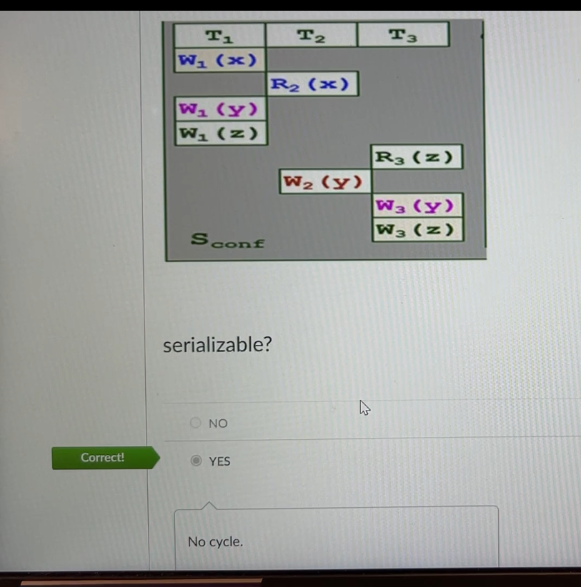

With a cold backup, recovery from storage media failure reads the log:

From the latest checkpoint

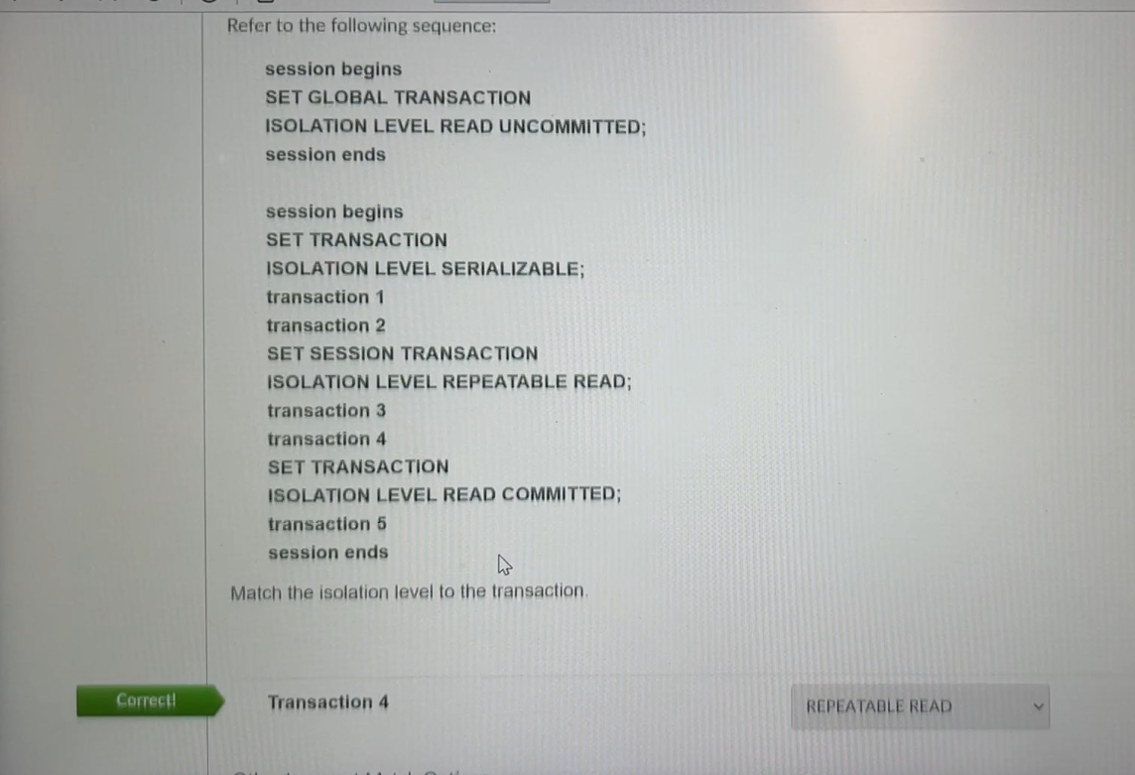

Which of the following is NOT true of the two-phase locking protocol?

It eliminates the problem of deadlock

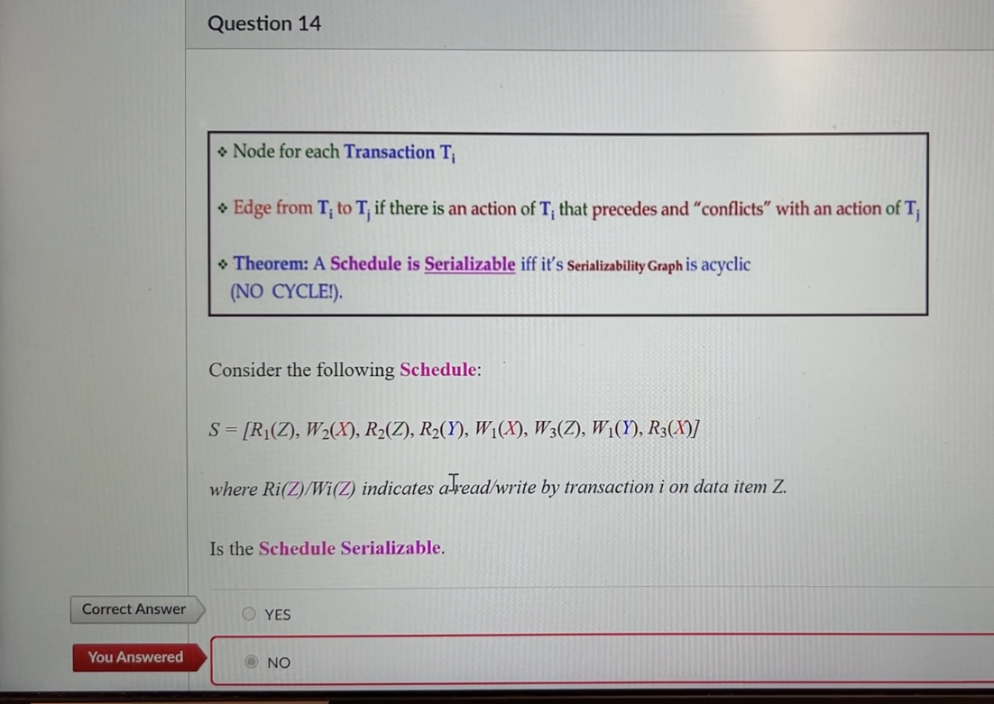

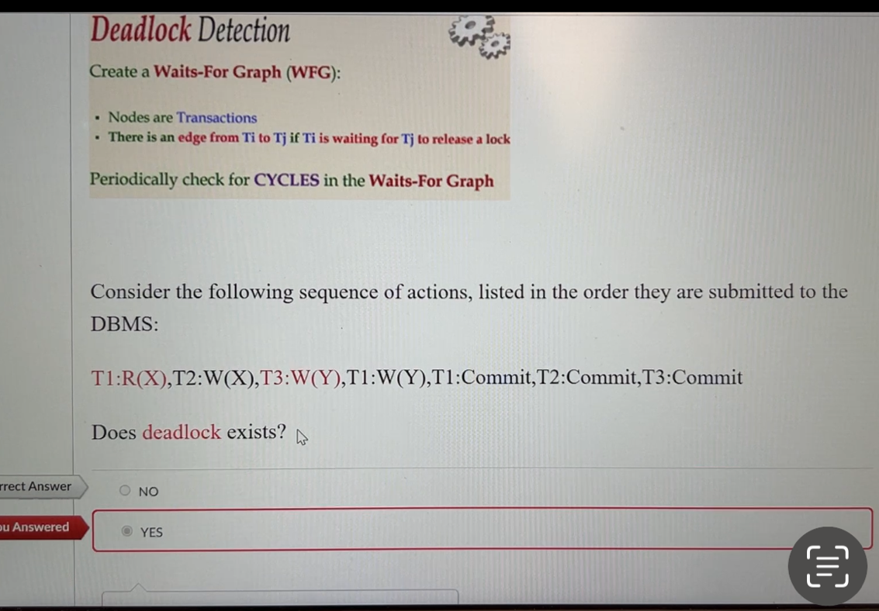

The concurrency control protocol in which transactions hold their exclusive locks until commit is called

Strict two-phase locking

The transaction is always atomi₫

False

Transaction A writes data and rolls back before transaction B reads the data.

Strict

When two READ UNCOMMITTED transactions run concurrently, the result may vary.

True

Procedures that monitor actions such as changes to the database and cause an action to be taken when certain conditions arise are called

Triggers

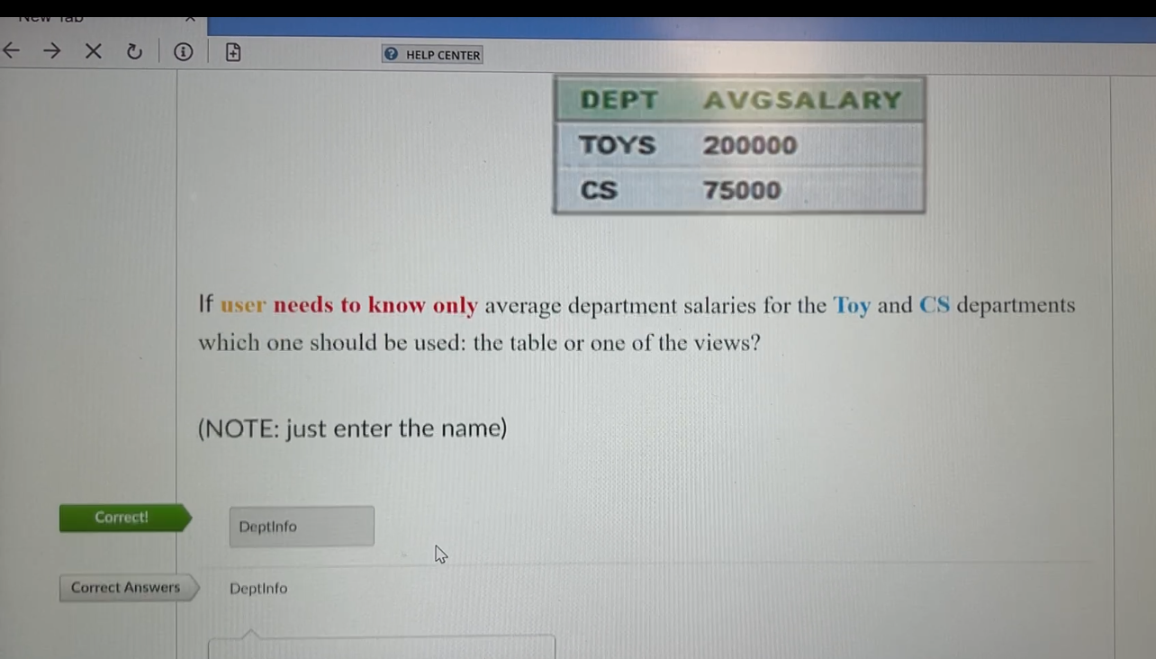

Is this schedule

T1:R(X), T2:W(X), T1:W(X), T2: commit, T1: commit

strict?

No

Undo is written in the log whenever an update is reversed during a rollback.

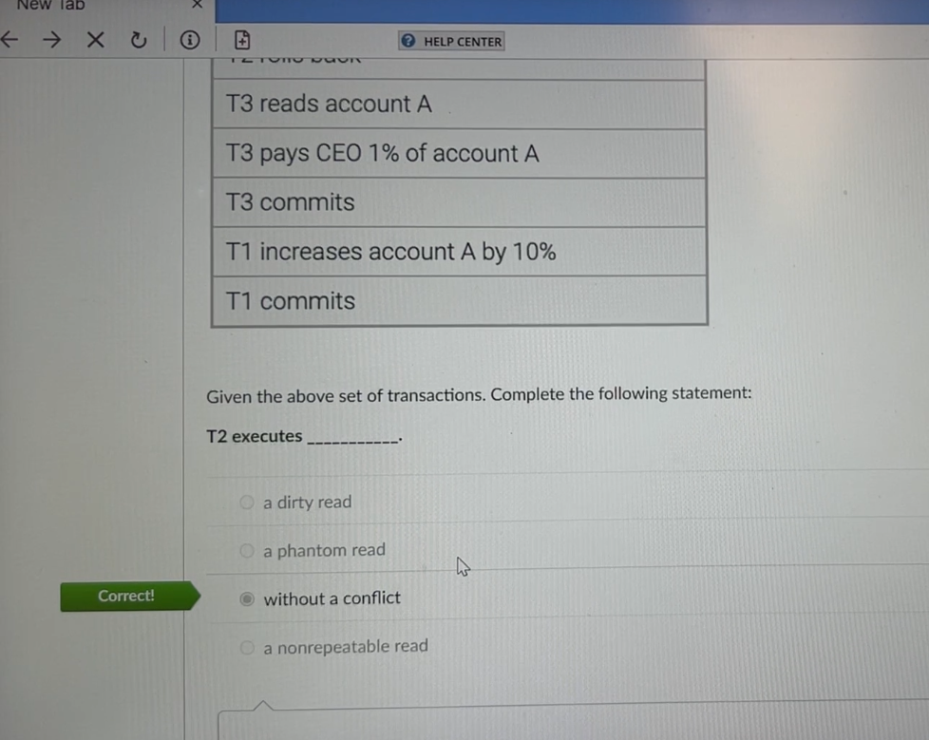

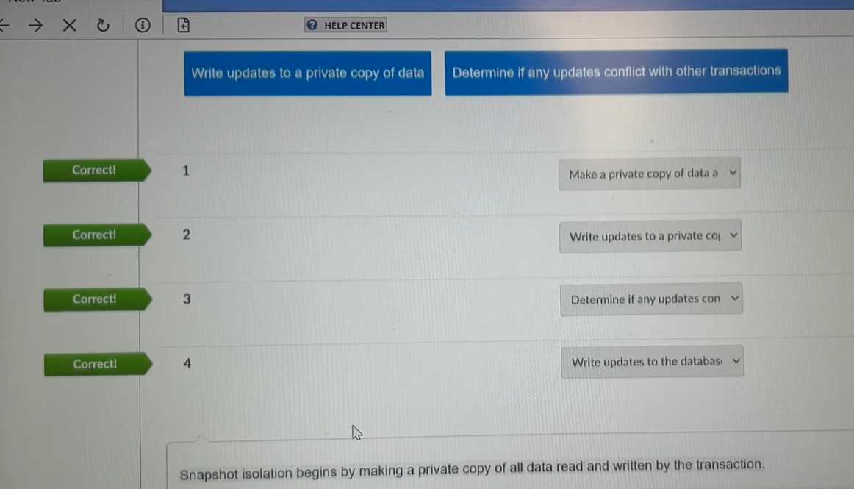

Is this schedule

T1:R(X), T2:W(X), T2: commit, T1: W(X), T1: commit, T3:R(X), T3: commit

strict?

Yes

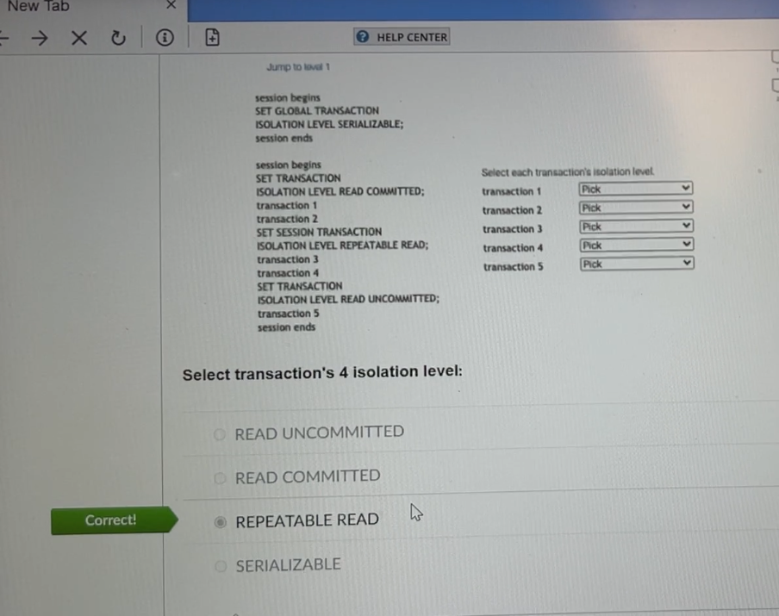

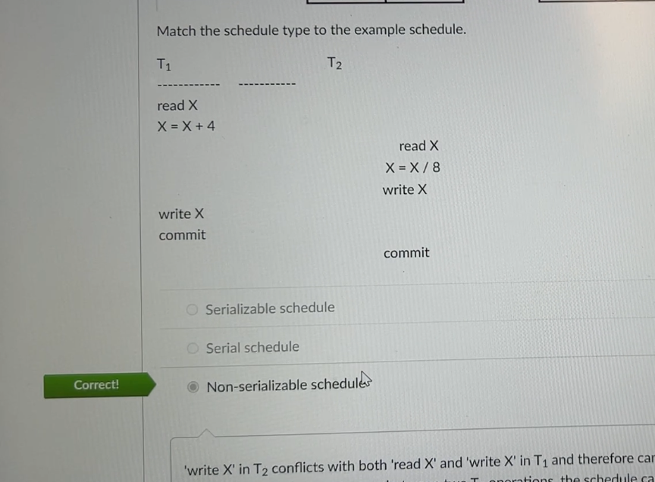

Transaction A writes data. Transaction B reads the data. Transaction A rolls back before B commits.

Cascading

According to the rules of two-phase locking protocol, every transaction can go through two phases: first, a shrinking phase, and then a growing phase.

False

Deadlock occurs when

two transactions each wait for a lock held by the other

A transaction with isolation level SERIALIZABLE can participate in a deadlock.

True

A SERIALIZABLE transaction can run concurrently with a READ COMMITTED transaction.

True

Phases in recovery using the ARIES method include all of the following EXCEPT

Synthesis

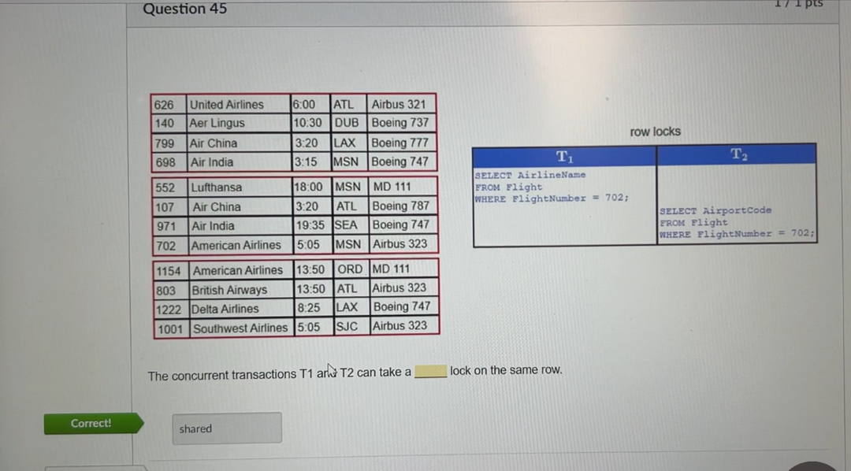

The privilege list of the SQL GRANT statement may include all of the following except

REPLACE

Whenever deadlock occurs, a cycle of dependent transactions always exists.

True

After all updates have been reversed in a rollback, a(n)

transaction record

Which two-phase locking technique has, in effect, just one phase?

Rigorous

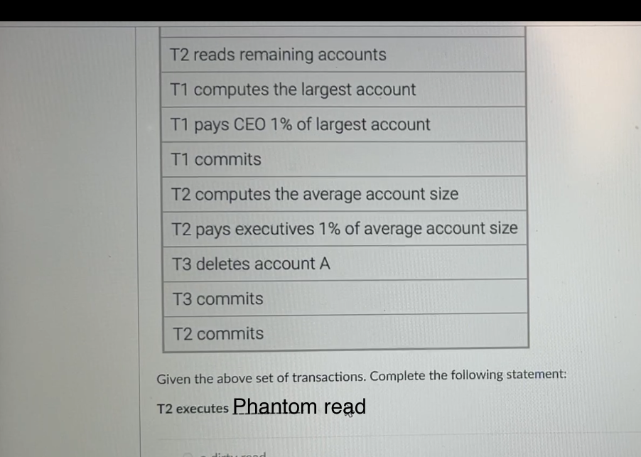

A(n) Start record always appears in the log at the beginning of a transaction.

Deadlock can occur in a serializable schedule.

False

Is this schedule

T2:R(X), T3:W(X), T3: commit, T1:W(Y), T1: commit, T2:R(Y), T2:W(Z), T2: commit

strict?

Yes

Is this schedule

wl(x) rl(x) w3(z) cl r2(x) r2(v) r4(z) c4 c2 r3(x) w3(v) c3

strict?

No

MySQL with InnoDB suspends processing during a checkpoint and restarts after a checkpoint record is written to the log.

False

A transaction updates all accounts with a BalanceAmount of NULL to 0.

The updates are written in the database, but due to a drive failure, the information is permanently lost.

Durable

Which two-phase locking technique results in the longest wait times for concurrent transactions?

Rigorous

The username and password for the database in the configuration file of a web application is incorrect, so the web application cannot connect to the database. Which failure scenario best describes this example?

Transaction failure

In an online bank application that transfers funds from a checking account to a savings account, the ____ property ensures that another transaction sees thetransferred funds in one account or the other, but not in both, nor in neither.

Isolation

A database admin uses a SHOW statement to retrieve information about objects in a database. This information is contained

Data dictionary

A database designer installs MySQL Community Edition to create a database. Which account does the designer use to gain full control of MySQL?

Root

In an online bank application that transfers funds from a checking account to a savings account, the _._ that the changes made to each account will not be lost due to a computer failure.

Durability

Which MySQL component retains data blocks from storage in main memory for possible reuse?

Buffer manager

Boundary indicates the starting and ending statement of a database transaction.

___allows all executed database instructions to be rolled back and to be restored in a prior transaction state.

SAVEPOINT

A recovery system should manage which three failure scenarios?

Transaction failure, System frilure, and Storage media failure